**Pom.xml**

<project xmlns="http://maven.apache.org/POM/4.0.0" xmlns:xsi="http://www.w3.org/2001/XMLSchema-instance" xsi:schemaLocation="http://maven.apache.org/POM/4.0.0 https://maven.apache.org/xsd/maven-4.0.0.xsd">

<modelVersion>4.0.0</modelVersion>

<groupId>com.cdac</groupId>

<artifactId>Spring-JDBC-App2</artifactId>

<version>0.0.1-SNAPSHOT</version>

<name>Spring-JDBC-App2</name>

<description>Spring JDBC App2</description>

<properties>

<spring.version>4.3.20.RELEASE</spring.version>

<aspectj.version>1.8.13</aspectj.version>

<mysql.connector.version>8.0.13</mysql.connector.version>

</properties>

<dependencies>

<dependency>

<groupId>org.springframework</groupId>

<artifactId>spring-core</artifactId>

<version>${spring.version}</version>

</dependency>

<dependency>

<groupId>org.springframework</groupId>

<artifactId>spring-beans</artifactId>

<version>${spring.version}</version>

</dependency>

<dependency>

<groupId>org.springframework</groupId>

<artifactId>spring-context</artifactId>

<version>${spring.version}</version>

</dependency>

<dependency>

<groupId>org.springframework</groupId>

<artifactId>spring-context-support</artifactId>

<version>${spring.version}</version>

</dependency>

<dependency>

<groupId>org.springframework</groupId>

<artifactId>spring-jdbc</artifactId>

<version>${spring.version}</version>

</dependency>

<dependency>

<groupId>org.springframework</groupId>

<artifactId>spring-orm</artifactId>

<version>${spring.version}</version>

</dependency>

<dependency>

<groupId>org.springframework</groupId>

<artifactId>spring-web</artifactId>

<version>${spring.version}</version>

</dependency>

<dependency>

<groupId>org.springframework</groupId>

<artifactId>spring-webmvc</artifactId>

<version>${spring.version}</version>

</dependency>

<dependency>

<groupId>org.springframework</groupId>

<artifactId>spring-aop</artifactId>

<version>${spring.version}</version>

</dependency>

<dependency>

<groupId>org.aspectj</groupId>

<artifactId>aspectjrt</artifactId>

<version>${aspectj.version}</version>

</dependency>

<dependency>

<groupId>org.aspectj</groupId>

<artifactId>aspectjweaver</artifactId>

<version>${aspectj.version}</version>

</dependency>

<dependency>

<groupId>mysql</groupId>

<artifactId>mysql-connector-java</artifactId>

<version>${mysql.connector.version}</version>

</dependency>

</dependencies>

</project>

**cfg.xml**

<?xml version="1.0" encoding="UTF-8"?>

<beans xmlns="http://www.springframework.org/schema/beans"

xmlns:xsi="http://www.w3.org/2001/XMLSchema-instance"

xmlns:aop="http://www.springframework.org/schema/aop"

xmlns:context="http://www.springframework.org/schema/context"

xmlns:jdbc="http://www.springframework.org/schema/jdbc"

xmlns:mvc="http://www.springframework.org/schema/mvc"

xmlns:p="http://www.springframework.org/schema/p"

xsi:schemaLocation="http://www.springframework.org/schema/beans http://www.springframework.org/schema/beans/spring-beans-4.3.xsd http://www.springframework.org/schema/aop http://www.springframework.org/schema/aop/spring-aop-4.3.xsd http://www.springframework.org/schema/context http://www.springframework.org/schema/context/spring-context-4.3.xsd http://www.springframework.org/schema/jdbc http://www.springframework.org/schema/jdbc/spring-jdbc-4.3.xsd http://www.springframework.org/schema/mvc http://www.springframework.org/schema/mvc/spring-mvc-4.3.xsd">

<context:component-scan base-package="com.cdac"></context:component-scan>

<bean id="dataSource"

class="org.springframework.jdbc.datasource.DriverManagerDataSource">

<property name="driverClassName"

value="com.mysql.cj.jdbc.Driver"></property>

<property name="url"

value="jdbc:mysql://localhost:3306/pune?userSSL=false"></property>

<property name="username" value="root"></property>

<property name="password" value="cdac"></property>

</bean>

<bean id="jdbcTemplate"

class="org.springframework.jdbc.core.JdbcTemplate" autowire="byType">

<property name="dataSource" ref="dataSource"></property>

</bean>

</beans>

**Car.java**

package com.cdac.model;

import org.springframework.stereotype.Component;

@Component

public class Car {

private int id;

private String make;

private String model;

private double price;

public Car() {

}

public Car(int id) {

this.id = id;

}

public Car(String make, String model, double price) {

this.make = make;

this.model = model;

this.price = price;

}

public int getId() {

return id;

}

public void setId(int id) {

this.id = id;

}

public String getMake() {

return make;

}

public void setMake(String make) {

this.make = make;

}

public String getModel() {

return model;

}

public void setModel(String model) {

this.model = model;

}

public double getPrice() {

return price;

}

public void setPrice(double price) {

this.price = price;

}

@Override

public String toString() {

return id + " " + make + " " + model + " " + price;

}

}

**CarDao.java**

package com.cdac.dao;

import java.util.List;

import com.cdac.model.Car;

public interface CarDao {

public void save(Car car);

public void update(Car car);

public void deletById(int id);

public Car selectById(int id);

public List<Car> selectAllCars();

}

**CarDaoImpl.java**

package com.cdac.dao;

import java.util.ArrayList;

import java.util.List;

import org.springframework.beans.factory.annotation.Autowired;

import org.springframework.jdbc.core.JdbcTemplate;

import org.springframework.stereotype.Repository;

import com.cdac.model.Car;

@Repository

public class CarDaoImpl implements CarDao {

@Autowired

private JdbcTemplate jdbcTemplate;

@Override

public void save(Car car) {

jdbcTemplate.update("insert into Car (make, model, price) values ('" + car.getMake() + "','" + car.getModel()

+ "','" + car.getPrice() + "')");

}

@Override

public void update(Car car) {

jdbcTemplate.update("update Car set make = '" + car.getMake() + "', model = '" + car.getModel()

+ "', price = '" + car.getPrice() + " where id = " + car.getId());

}

@Override

public void deletById(int id) {

jdbcTemplate.update("delete from Car where id = " + id);

}

@Override

public Car selectById(int id) {

return jdbcTemplate.query("select * from Car where id = " + id, rs -> {

Car car = new Car();

if (rs.next()) {

car.setId(rs.getInt(1));

car.setMake(rs.getString(2));

car.setModel(rs.getString(3));

car.setPrice(rs.getDouble(4));

}

return car;

});

}

@Override

public List<Car> selectAllCars() {

return jdbcTemplate.query("select * from Car", rs -> {

List<Car> cars = new ArrayList<Car>();

while (rs.next()) {

Car car = new Car();

car.setId(rs.getInt(1));

car.setMake(rs.getString(2));

car.setModel(rs.getString(3));

car.setPrice(rs.getDouble(4));

cars.add(car);

}

return cars;

});

}

}

**CarService.java**

package com.cdac.service;

import java.util.List;

import com.cdac.model.Car;

public interface CarService {

public void add(Car car);

public void update(Car car);

public void removeById(int id);

public Car getById(int id);

List<Car> getAllCars();

}

**CarServiceImpl.java**

package com.cdac.service;

import java.util.List;

import org.springframework.beans.factory.annotation.Autowired;

import org.springframework.stereotype.Service;

import com.cdac.dao.CarDao;

import com.cdac.model.Car;

@Service

public class CarServiceImpl implements CarService{

@Autowired

private CarDao carDao;

@Override

public void add(Car car) {

carDao.save(car);

}

@Override

public void update(Car car) {

carDao.update(car);

}

@Override

public void removeById(int id) {

carDao.deletById(id);

}

@Override

public Car getById(int id) {

return carDao.selectById(id);

}

@Override

public List<Car> getAllCars() {

return carDao.selectAllCars();

}

}

**Main.java**

package com.cdac;

import org.springframework.context.ApplicationContext;

import org.springframework.context.support.ClassPathXmlApplicationContext;

import com.cdac.model.Car;

import com.cdac.service.CarService;

public class Main {

public static void main(String[] args) {

ApplicationContext appCntx = new ClassPathXmlApplicationContext("cfg.xml");

CarService carService = (CarService)appCntx.getBean(CarService.class);

Car car1 = new Car("Audi", "Q2", 40.5);

Car car2 = new Car("THAR", "2.0", 60.5);

Car car3 = new Car("Tata SAfari", "2.0", 90.5);

Car car4 = new Car("Xcent", "I10", 40.5);

carService.add(car1);

carService.add(car2);

carService.add(car3);

carService.add(car4);

System.out.println("Car added successfully");

// carService.removeById(11);

// System.out.println("Car removed successfully");

}

}

**Project Structure**

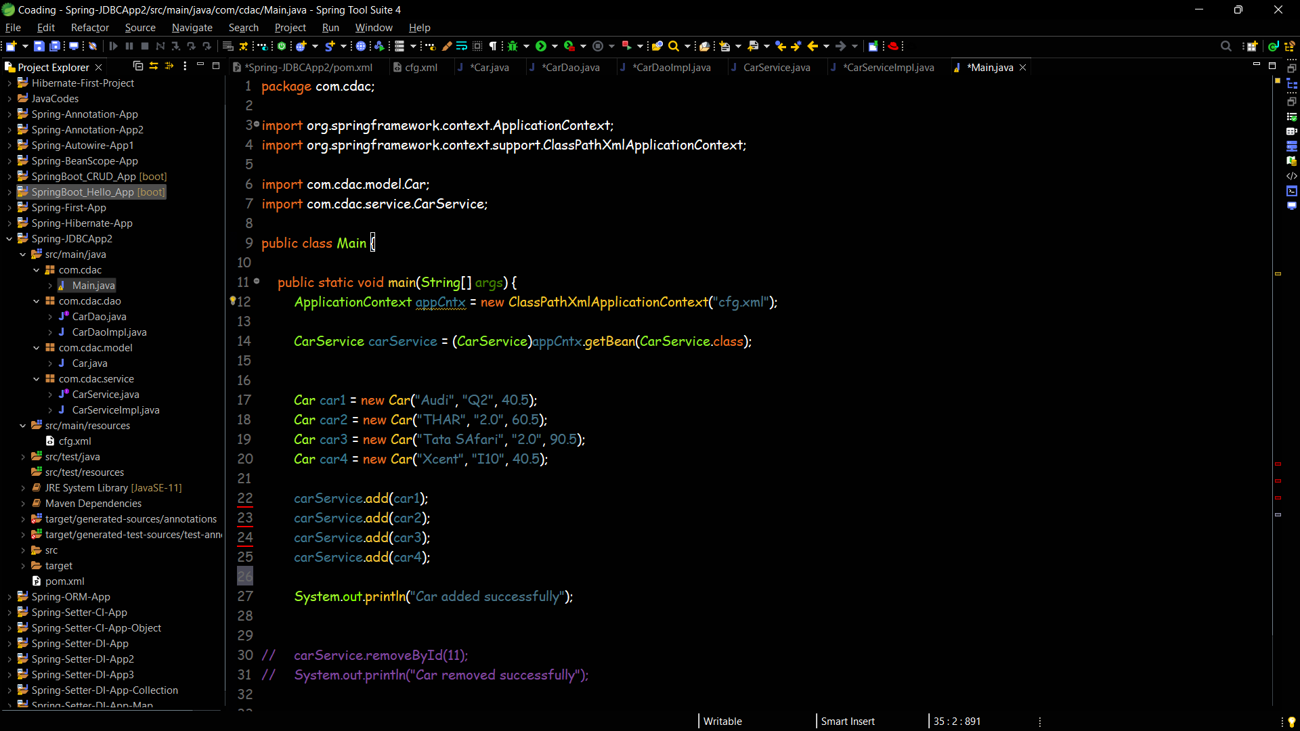

**Database Data**

